Checkout

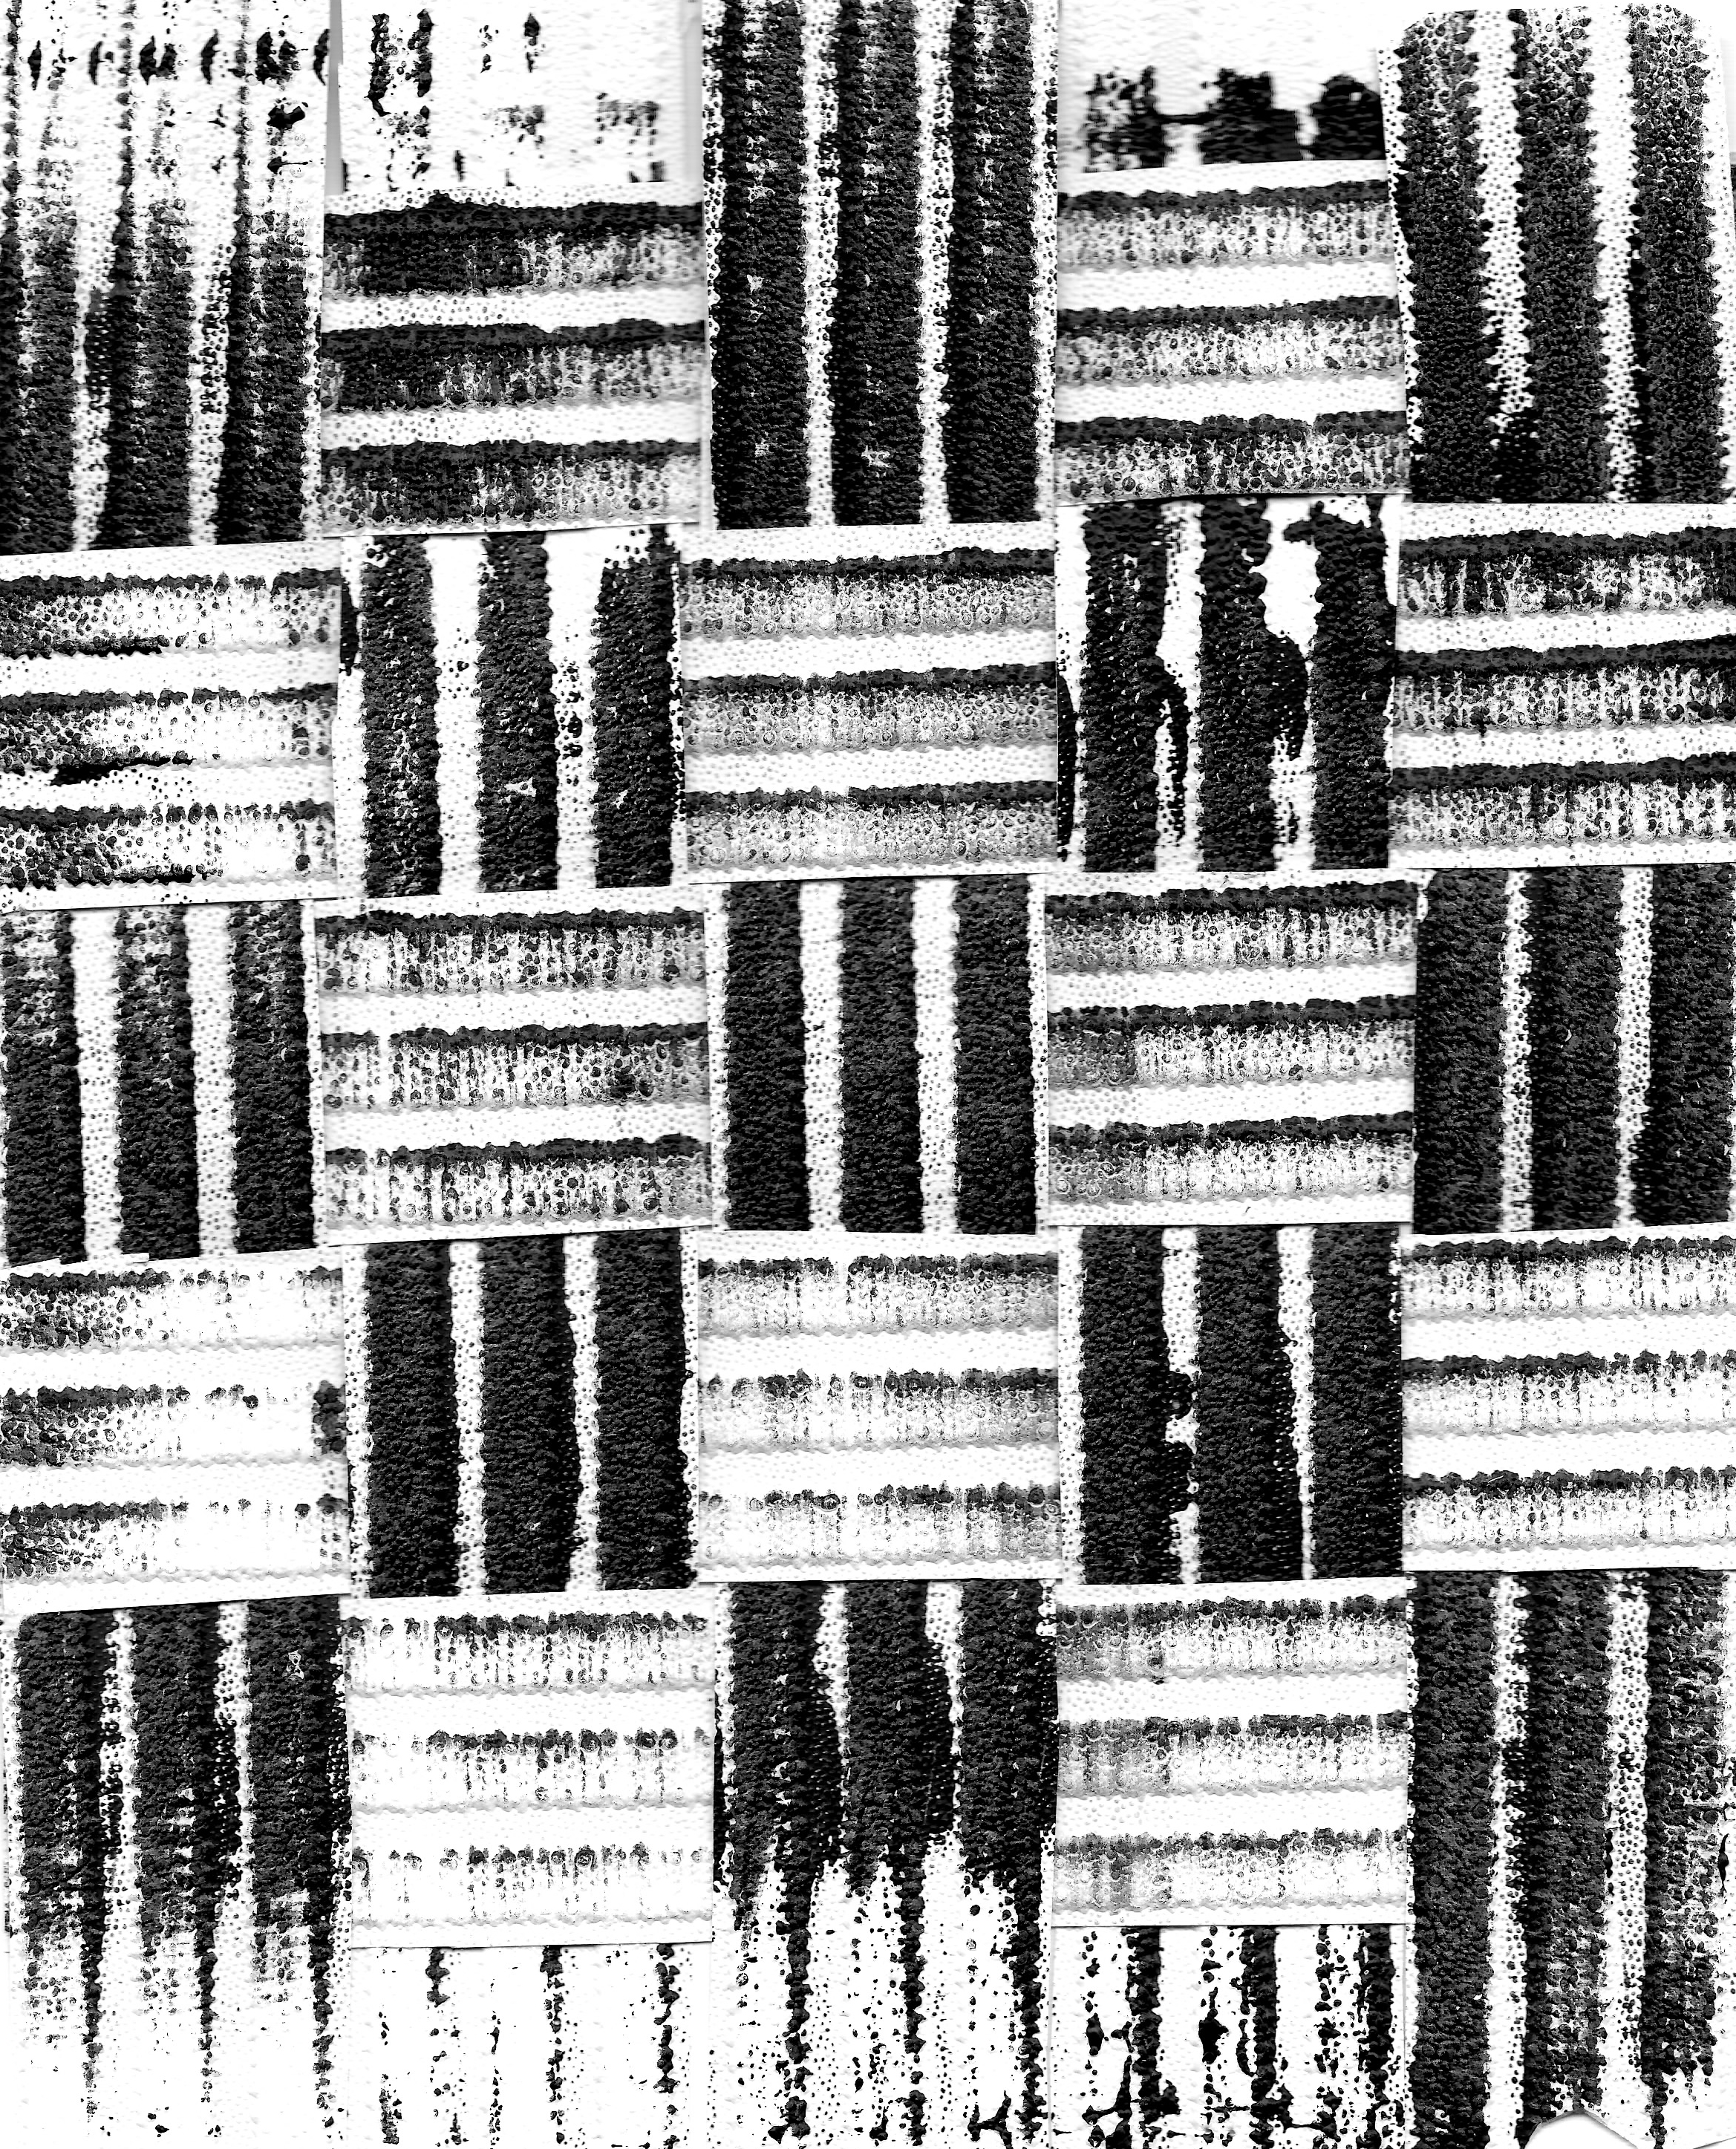

Reader’s notes
Kathy Gee
2019
Checkout - page 1

In early drafts, Checkout was only a temporary file name. However, as I worked on bringing all the poems together, I became rather attached to the title and all its different connotations:
- Checkout – pay here
- Check out – look at that!
- Check out – leave for good
- Check – make sure something is as expected
- Check – or tick (as in marking)
- Checked – as in woven tartan
- Check mate – when one piece cannot move

Checkout - page 5

“You can always make something out of what you’ve been made into”
(Jean-Paul Sartre, Situations IX)

“The first part of his [Sartre’s] professional life focused on the freedom of the existential individual (you can always make something out of …); the second concentrated on the socioeconomic and historical conditions which limited and modified that freedom (what you've been made into), … and included the possibility of genuine options in concrete situations.” Flynn, Thomas, "Jean-Paul Sartre", The Stanford Encyclopedia of Philosophy (Fall 2013 Edition), Edward N. Zalta (ed.),

A favourite aphorism of mine is ‘You can’t choose what happens to you, but you can choose how you respond to it’ (source unknown). The Sartre epigraph found me early in the process and both helped me to find a broadly positive stance for Nona and influenced which poems I chose to include.

Checkout - page 6

Nona really was the Roman goddess who spun the thread of life, but she is also, when spelled backwards, Anon, which pleases me. She could be anyone. My Nona is a caring young woman who, in her day job, is the unknowing witness to an interweaving of customers and stories.

The character poems were written over the last decade, stimulated by entirely separate observed or experienced events. When I gathered them together for the purposes of this book, I put them all into the first person and they took on an unexpected life of their own. Choosing names for these 28 customers was surprisingly difficult. I wanted to portray a town which is demographically mixed in terms of ethnicity, age and social environment, while trying hard to avoid stereotyping. Although ethnicity and family origin are rarely directly mentioned in the poems, I know that my characters include people of Vietnamese, North African, Polish, Jewish, Scandinavian and Turkish heritage.

In terms of location, the book’s demographic is modelled on that of my local county town. There are slightly more older customers here than you would find in Worcester, but that is typical of a corner shop or convenience store.

While the future of the high street is under pressure from online retailers and unsustainable rents, new economic models may eventually emerge from the old. However, we already know that losing the places where people meet and share experience has a deadly effect on social connections. Just ask any community which has lost its local shop.

Finally, a note about what I’ve called a duologue form. There are, of course, other poetry books where the poems are linked by a common narrative. In this case, I gave myself rules for the narrator’s prose poems, linking the two poems on each page by their presence in the same place. Nona’s pieces are strongly metric and 100 words long precisely. In flash fiction, the 100-word form is called a ‘drabble’. For me, these self-imposed rules are what make Nona’s inner voice speak in poetry rather than prose.

Checkout - page 7

Nona is the shop assistant in a smallish grocery store. She must be trusted with some responsibility because she is opening up in the morning. She’s about 20 years old, not particularly well off.

Adam: Down on my luck
Adam’s language is quite educated. I imagine him as someone in his thirties who’s lost his job, marriage and home relatively recently. In future he might become addicted to drugs or alcohol (notice the beer cans). The clue is in the title.

The charity Homeless Link estimates rough sleeping across the UK went up by 15 per cent between 2017 and 2018, with 4,751 people thought to be sleeping rough on any one night. (Express and Star, May 2018)

Checkout - page 8

The man in black: Stage door
I was having breakfast in an hotel across the road from the Royal Shakespeare Theatre at Stratford upon Avon when I watched this man arrive at work. His habitual, regular movements caught my eye, and I invented a story for him. While this poem is about ambition, I think it is it is also about taking pride in one’s work. By the way, while I didn’t consciously choose the play, I realise now that ‘last night’s show’ must be influenced by A Midsummer Night’s Dream.

Checkout - page 9

Helen: Knuckles firmly rapped
Helen’s (unnamed) friend is a doctor.
I had this conversation, or one very like it, with a GP friend. She introduced me to the beauty of the nine times table and, of course, the sevens - medicines prescribed by the week, and contraception pills taken for three weeks with one week off for menstruation.
In the real world, I still flounder when I need to use arithmetic to make something happen and rely on my phone-calculator. I get by, but I really do wish I had paid more attention to the lesson on compound interest.

Checkout - page 10

In my lifetime, the significance of the building society as a safe place for savings and provider of mortgages has waned. Apparently, many millennials don’t know the difference between a bank and a building society and, daunted by low interest rates on savings and the size of the deposit needed to get on the property ladder, are likely to start saving much later in life. Nona will probably be one of many who live in rented property all of their lives.

Richard: Alfa Romeo
An ‘Alfa Romeo’ is an expensive sports car. Their team race in Formula One. The name is Italian and implies ‘the best’ (Alpha / Alfa) ‘lover’ (Romeo – after Shakespeare’s character)

Checkout - page 11

bạn – (notice the dot under the ‘a’) is Vietnamese for friend.

Dac-Kien: My life in bowls
This character must have grown up in Vietnam during the late 1970s. The Mekong river flows north to south from China, through Laos and Cambodia, to Vietnam. Fishing communities were severely affected by both https://en.wikipedia.org/wiki/Vietnam_War (1955 – 1975) and https://en.wikipedia.org/wiki/Cambodian_genocide (1975-1979).

This poem was originally written in the third person, inspired by conversations I had while travelling on the Mekong in 2011. I only changed the poem to first person to fit in with this collection. This could now lay me open to accusations of cultural appropriation, although the character is completely fictional. https://en.wikipedia.org/wiki/Cultural_appropriation

Checkout - page 12

In this part of the narrative we begin to find out a little more about Nona’s background and why she is working as a shop assistant. She and her younger siblings have been brought up by their Nan. There is no mention of her mother and her father has disappeared.

Checkout - page 13

When I pause by the newspaper rack in a motorway service station, I’m fairly certain that most front-page news is not actually ‘news’ and I don’t trust it as much as I used to do.

“noun (usually used with a singular verb) (www.dictionary.com )
- a report of a recent event; intelligence; information: His family has had no news of his whereabouts for months.
- the presentation of a report on recent or new events in a newspaper or other periodical or on radio or television.
- such reports taken collectively; information reported: There's good news tonight.“

Roxy: Collie in control
This poem is in the voice of Walter’s dog. Collies are excellent sheepdogs and Roxy is keeping her little flock of humans in order. Walter is named after my step-grandfather who was indeed ‘a retired beer-bottler from Wolverhampton’. This poem was begun on a narrowboat poetry workshop conducted by Jo Bell.

Checkout - page 14

This section of Nona’s narrative was written during the #MeToo movement in 2018. I wanted to echo young friends’ conversations about acceptable and unacceptable touching, but I found it very hard to get the whole debate into my self-imposed 100-word limit.

Pete: You, me, the sun and the sea
Pete might be gay, or he might not. The poem is deliberately genderless. Love is universal.

Checkout - page 15

Miss Francis: Not love
The stanzas reduce in length as the strength of the affection grows stronger. By the end, she doesn’t need many words to express her lost love.

There is a sofa just inside my front door and everyone who enters my house drapes their tools and personal belongings over its back. The poem was originally called ‘Finding love down the back of the sofa’.

Checkout - page 16

The ‘fourteen bug-eyed monsters’ are, of course, the ubiquitous security cameras. The shop assistant can see all of them in real-time on a multi-screen above her till. I know I am not sufficiently conscious of how much I am monitored in my daily life.

Lulu - Plaything
The name Lulu is of Arabic origin, meaning Pearl. She is probably about 17. Trevor is older and has a roaming eye (see page 18) and we discover later that he is already married (see page 29).
I think these experiences and emotions cross ethnic and social stereotypes, and of course, it doesn’t only happen to young women. Or, indeed, only to women.

Clues in this poem are his control of the date and the quiet park, and then paying for their meal in cash so it doesn’t turn up on his bank statement. The title is another clue.

Checkout - page 17

Lew: My eulogy

Lew is based on my old friend and dog-sharer Lewis Howe-Bennett who is a professional water colour artist (born 1934).

Like all young men of his generation, Lew did two years ‘National Service’. In his case, he served in Wiltshire, packing munitions for the Korean War.
- “Conscription in the United Kingdom has existed for two periods in modern times. The first was from 1916 to 1920, the second from 1939 to 1960, with the last conscripted soldiers leaving the service in 1963. Known as Military Service from 1916 to 1920, the system of conscription from 1939 to 1960 was called National Service.” (https://en.wikipedia.org/wiki/Conscription).

Checkout - page 18

It’s not fair for Nona to say that ‘school chucked me out’ when she fell pregnant. Schools wouldn’t do that these days, but it’s how she felt.
https://www.babycentre.co.uk/x1043670/im-school-age-and-pregnant-can-i-keep-my-education-going

Trevor: Brief Encounter
We’ve met Trevor before, flirting with Lulu on page 16. He obviously hasn’t learnt his lesson.

Every town used to have a huge, circular gasometer (ɡaˈso mɪtə) for storing household gas. Many of them have now been dismantled. https://en.wikipedia.org/wiki/Gas_holder

Brief Encounter is a famous film from the 1940s. https://en.wikipedia.org/wiki/Brief_Encounter The only way that my poem echoes the film is that two people meet in a railway station. Otherwise, that story is nothing like this one! The leading male actor in the film was Trevor Howard, which is where I got this character’s name.

Checkout - page 19

Many northern English surnames have Scandinavian origins, dating back to the Viking invasions. Raven is one of those surnames. Eva and Anita are modern Nordic names though, so the family might have come to this country in more recent times.

Many people have mini-strokes without realizing it, but these can signal the potential for a more major episode which is what is described in this poem. Recognising the signs is important:
https://www.nhs.uk/conditions/stroke/symptoms/ .
“A blood clot can block the flow of blood and oxygen to the brain, if the arteries have been narrowed or blocked over time by fatty deposits. Certain things can dangerously accelerate the process: smoking, high blood pressure, obesity, high chlorestoral / diabetes, excessive alcohol. “

Eva: Last request
This is my own story. This was my father, my mother, our exact conversation. I wish there had been a way I could have said yes but, to my eternal sorrow, I was more nervous about breaking the law than showing my love through assisted suicide or euthanasia. There should have been a better way.

Checkout - page 20

Jayne: Better than waiting in for the postman
I imagine Jayne as in her late 40’s, early 50’s, although her husband (Rich the Rude, page 10) imagines he is still a younger man. She doesn’t have to work because they are well off, but she’s clearly bored and a little lonely.

This poem was massively edited from a prose piece that I wrote after reading, and falling in love with, Mrs Dalloway by Virginia Woolf. I tried to emulate Woolf’s stream of consciousness by sitting in the garden and dictating into a voice recorder, then transcribing it in full. The first script was over three pages long.

Checkout - page 21

Nona is becoming more frustrated in her job. People ignore her, and she is almost treated like a machine … ‘Is this who I was born to be?’

Planning offices sometimes get a bad press, ensuring that building projects meet national standards and local priorities for development. I am on their side – our towns and villages would be worse without them. https://www.rtpi.org.uk/education-and-careers/become-a-planner/ .

Andrew: Redundant
In an employment situation, legally it is the POST that is redundant (ie there is no longer the need for anyone to do that job), not the person who currently holds the post. However, when an individual is told that their post is surplus to needs, they will very often hear the word redundant and think ‘worthless’. I’ve been there. It’s very painful.

There is a well-known poetry mantra ‘show don’t tell’. This poem uses metaphor to express Andrew’s emotions: cliff, fog, shore, float and swim, portraying fear, depression, uncertainty, hope, determination.

Checkout - page 22

Depression is defined as ‘feelings of severe despondency and dejection’ and is recognised as a medical condition requiring treatment. ‘1 in 6 people report experiencing a common mental health problem (such as anxiety and depression) in any given week’

https://www.mind.org.uk/.../types.../how-common-are-mental-health-problems/

‘Confident as sugar lumps in Yorkshire Tea’. What?! These days, taking sugar in your tea is almost sneered at; Yorkshire tea is always strong and sugar lumps are angular and deemed old fashioned. In other words, Nona wants to be confident enough to do what she likes, regardless of what other people think.

Anna: Warm front
The title relates to weather. A warm front is a transition zone where a warmer air mass is replacing a cooler air mass.

This poem described all the good things that I suddenly noticed when I emerged from a period of mild depression. I told a friend that ‘everything has leapt into three dimensions’, meaning that instead of being flat, distant and pale, life was clear, immediate and present.

Checkout – page 23

Cappadocia, in Eastern Turkey is famous for its underground cities and the curious rock houses carved into volcanic tufa. It is also very fertile agricultural land. Apricots, pumpkins, melons, sugarcane, beets and chickpeas are grown there.

Istanbul spreads across the Bosphorus, linking the continents of Europe and Asia. The old city is famous for its superb mosques. https://en.wikipedia.org/wiki/Istanbul , http://www.sultanahmetcamii.org/

Pembe: Snow in Istanbul
Pembe is a Turkish name meaning Pink. Pembe’s mood changes over the course of the poem. In stanza one – she’s angry, resentful. In stanza two – she starts again. By stanza three, I think she’s mildly amused!

This poem is a complete fabrication, combining half-truths with story-telling. I wish I could remember more, but my unreliable memories are these:
- a visit to Istanbul Modern where two paintings particularly caught my eye. One was a splash painting, another a townscape of Istanbul in the snow.
- a news report that an artist was suing her dealer for selling the floor of her studio as an artwork.

Checkout - page 24

I have been lucky, my professional career in heritage has given me huge job satisfaction (alongside some very stressful management problems, of course). I sometimes wonder whether we all define ‘job satisfaction’ in the same way. For me, it’s never been about money.

Miss Armstrong: Invisible woman
It’s generally agreed (amongst women of a certain age) that there is a point at which women suddenly feel they have become invisible. Waiters and barmen don’t see us, taxis don’t stop for us. My solution is to become noisily and outrageously noticeable.

‘After Maya Angelou’.
One evening, in a small bistro in Bowness on Windermere, I was reading Maya Angelou’s autobiography I know why the caged bird sings. I had already noticed that, due to some trick of the light, my reflection didn’t appear in the window, but it wasn’t until I read her line ‘a silent shadow that played infrequently along the walls’, about women whose men had left, that the poem wrote itself.

Checkout - page 25

All hail citizen protest: https://en.wikipedia.org/wiki/Right_to_protest and long may it last. I do worry, though: https://en.wikipedia.org/wiki/Freedom_of_speech_by_country

Nona uses slang and casual grammar. In this book, I have been challenged by the difference between spoken English and written English. I sometimes found it hard, as an educated woman trained in civil-servant-speak, to use my everyday speech.
- https://www.quora.com/What-are-the-main-differences-between-spoken-English-and-written-English

Peregrine: Falcon’s lunch
This poem is in the voice of a peregrine falcon which nests on the artificial ‘cliff’ of a church tower. Several cities have live web-cams – http://worcestercity.org.uk/peregrine/

- “In ancient Greek, Nemesis is the goddess who enacts retribution against those who succumb to hubris (arrogance before the gods)”.
- Canticles are “a hymn or chant, typically with a biblical text, forming a regular part of a church service”. (Wikipedia)

Checkout - page 26

Julia (pronounced Yulia in Polish) has obviously been brought up in this country. Her parents and aunt may have come to live here under the Polish Resettlement Act after WW2. https://www.japantimes.co.jp/news/2014/05/04/world/a-glance-at-the-history-of-polish-immigration-to-u-k/#.W_xEYDGny70

Checkout - page 27

Red Admiral - https://butterfly-conservation.org/butterflies/red-admiral
Painted Lady - https://butterfly-conservation.org/butterflies/painted-lady

Nicki: A moment of everyday beauty
Although the poem is about Mr Barrett, it is narrated by his daughter, Nicki.
Berber twist is a kind of woolen, fitted carpet, often neutral and mottled in colour, which was very popular in the 1980s. https://en.wikipedia.org/wiki/Berber_carpet.
The human eye can distinguish over a million colours, but English has a very limited range of words for them – e.g. fawn, beige, mushroom, neutral, taupe, pale khaki, coriander, buff etc. Many of them refer back to a ‘thing’, eg fawn, mushroom, coriander.

Rod Stewart : I don’t want to talk about it. https://www.youtube.com/watch?v=esUHMBHJsn8

Checkout - page 28

This is the moment when Nona’s dream of college becomes real. When she talks about it (rather than just thinking about it) her subconscious becomes conscious. She begins to believe in herself.

Jamie: Team meeting
Another fabrication. I noticed the white-streaked ridge tiles and seagulls when I was bored in a meeting. The reluctant insurance man who became a paramedic is my godson.

Checkout - page 29

Mrs Trevor: The attractions of divorce
Trevor may not know it yet, but Trevor has been rumbled. His wife is thinking of leaving him.

Red Breton chinos? Actually, the colour is properly described in the UK as Breton Red. It’s my belief that they are favoured by well-off men of a certain age. That certainly seems to be the case in the USA: https://www.racked.com/2017/5/26/15582858/nantucket-reds-pants-history

Checkout - page 30

Kiddy: Playing lipstick
The pretty weed with ‘pale green, milky stem’ and ‘sappy fluid’ is Petty Spurge: https://www.gardenorganic.org.uk/weeds/petty-spurge. The sap is toxic and can cause blisters.
The weeds grew in the gravel under our car when I was a child. I think we must have been going to see my parent’s friends, so washing the sap from my lips was yet another nuisance.

Checkout - page 31

Most eggs in supermarkets are still mass produced by chickens that live their lives indoors, sometimes in crates, in factory farms. https://www.peta.org/issues/animals-used-for-food/factory-farming/chickens/egg-industry/ These days, there are various different standards of animal welfare, but those labelled Free Range are eggs produced from birds that ‘may be permitted’ outdoors. They are usually more expensive.

Colin: Scrumpy
Scrumpy is a dialect term for a rough cider made from unselected apples. Although for the purposes of this publication, Colin and Susan are twins, these two poems were actually written several years apart, in different parts of the country, about unrelated people.

Checkout - page 32

Nona is feeling good. She can see that she has opportunities, choices.

Susan: Caught in the headlights
When I was living in South Devon, I was stupidly soft-hearted and did nothing about the first few mice I saw in our kitchen. This led to a mini-plague. We caught 16 over three days, sometimes finding two babies in the trap at once. By the way, when using a humane mousetrap, it’s important to release them at least half a mile away, or they just come back.

Checkout - page 33

Nona is really looking a long way ahead now. Although she could go to college and stay at her Nan’s, in future years she might have to move to another town.

By the name we know that Mr Levi is Jewish, and bagel chips reinforce that idea. Nona obviously knows about the Holocaust but is too embarrassed to talk to him about it.

Mr Levi: Ghetto
This poem was inspired by two trains of thought in Budapest. First, in the Synagogue memorial garden, I noticed that many of the stones had birth dates but either no death date at all, or only a rough estimation. I speculated that these people were murdered in the Holocaust with no known date of death. Second, in WW2, Budapest was besieged by Soviet forces c80% of its buildings were destroyed or damaged. https://en.wikipedia.org/wiki/Siege_of_Budapest In a massive effort of reconstruction, much has been rebuilt as it originally was. I wondered whether someone coming back to a reconstructed building would still feel that it was ‘home’.

Checkout - page 34

Nona has made a decision. We don’t know whether she will carry it through, but decisions of this magnitude don’t happen in the space of one day.

Although it is laid out in a different format to the other pages, Nona’s narrative is still precisely 100 words. I wanted to use the space on the page to give Nona’s story a visual ending.

Checkout - page 35

Poet’s postscript: One day I’ll take you there.
This is a ‘double drabble’ – precisely 200 words.

This is my world, or rather, these are some of my worlds. I’ve worked in areas of the UK which could be said to represent either decline or success. Like me, every Nona ought to be able to move towards a better future, however she defines success, however she chooses to travel.

Checkout - page 36

This page in the book is my formal biography. The kind of thing I might put in a CV. But behind it, as with every life, there is more.

My father was an architectural historian, but he was brought up as the only surviving child of a single mother who eventually ran a small corner shop in the Black Country. The shop was closed by the time I knew her, although Gran still occupied the first floor flat. Dad used to talk about the ‘custard powder ice cream’ which she sold to the miners. As for me, I was married for fourteen years to a third generation ‘gentleman’s outfitter’. He modernized the business, selling jeans and tee-shirts to holiday makers in Devon.

‘Book of Bones’, my first book, grew out of my profession as a museum curator. This one is fed by my fascination with what makes people tick.

